Log on to WGS using your email Password associated to your FAN attached to your ref account:

https://wholegame.thefa.com/Account/Login?ReturnUrl=%2f

Click Login and that will navigate you to the dashboard if your credentials were input correctly. On the dash board click the following TAB.



You will now be on the Referee’s dashboard, click Add Match.

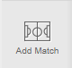

On the New Match Details screen, you need to use the options to select the game you were officiating.

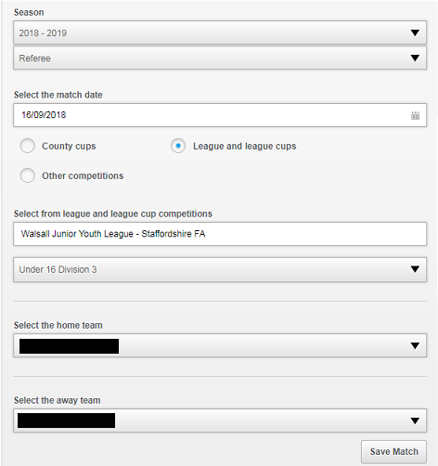

Click Save Match, you will then be re-directed to the referee’s report page.

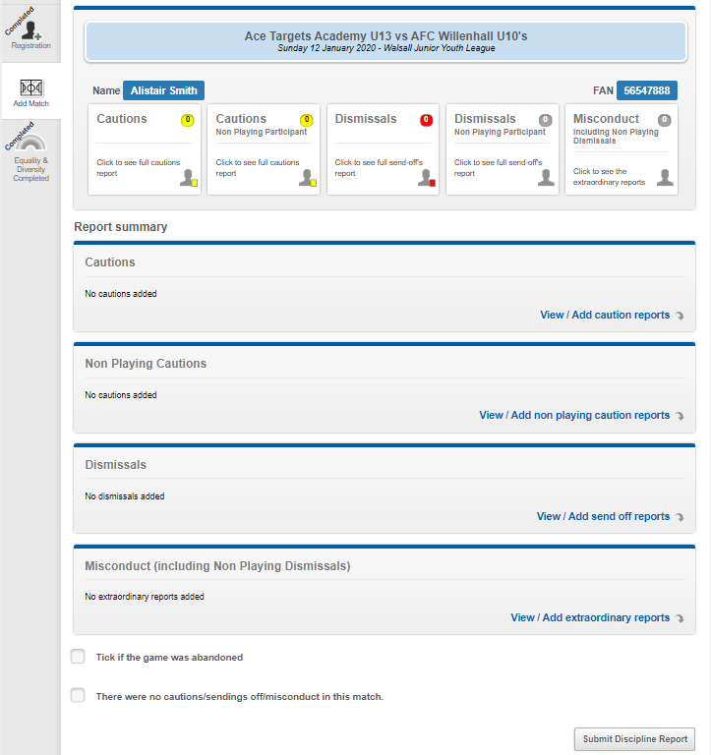

As you can see there are a number of options:

1. View / Add Caution Reports
2. View / Add Non Playing Caution Reports
3. View / Add Send off reports
4. View / Add extraordinary reports
5. Tick if the game was abandoned
6. There were no cautions/sendings off/misconduct in this match

For Yellow Card or Sin Bin Offences click View / Add Caution reports

To add a caution, click either > View / Add Caution Reports OR

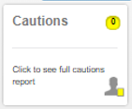

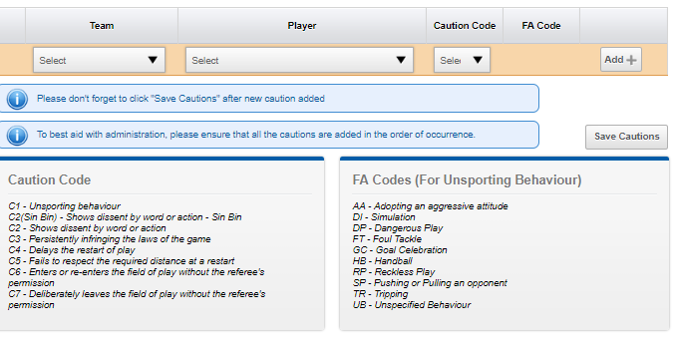

To add the caution(s) select the relevant team, player and using the chart below select the correct caution code.

As you can see - If you select C1 (unsporting behaviour) a second drop down under the FA Code will be visible. You will also need to select the appropriate FA Code in the right hand box that best matches the reason behind the C1 caution.

If the player receives any yellow card as a result of dissent by words or actions, you **MUST**  use the caution code C2(Sin Bin), there are two C2’s this is because not all leagues have signed up to the Sin Bin procedure for this season 2018/19. For WJYL refs you would **ONLY** use C2(Sin Bin) for dissent by word or action – Sin Bin.

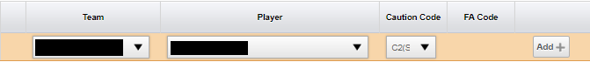

When you have selected the relevant team, person and code(s) click Add+

At this point you can add more cautions if you have some, again just select, team, player, code(s) and then click Add+ for each caution. Before you progress you must click Save Cautions.



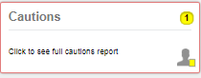 You can check cautions by clicking here.

When you have added all the relevant information scroll to the top of the page and click back to summary.



Non Playing Caution Reports

To add a caution, click either > View / Add Non Playing Caution Reports OR

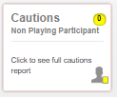

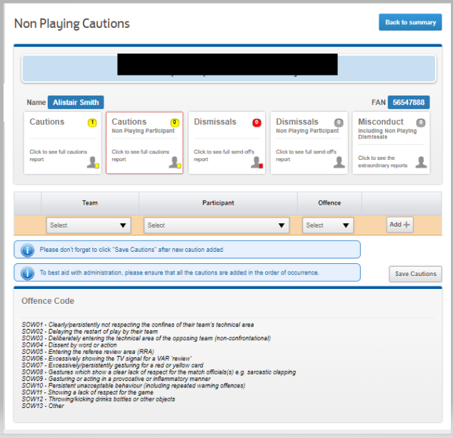

Again, select team, player and under law 12 section options and select the appropriate options and the appropriate offence that needs to be recorded.

When you have selected the relevant team, person and code(s) click Add+

At this point you can add more cautions if you have some, again just select, team, player, code(s) and then click Add+ for each caution. Before you progress, you must click Save Cautions.



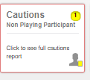 You can check cautions by clicking here.

When you have added all the relevant information scroll to the top of the page and click back to summary.



For Red Card Offences click View / Add Send Off reports

You will be navigated to Add New Dismissal page

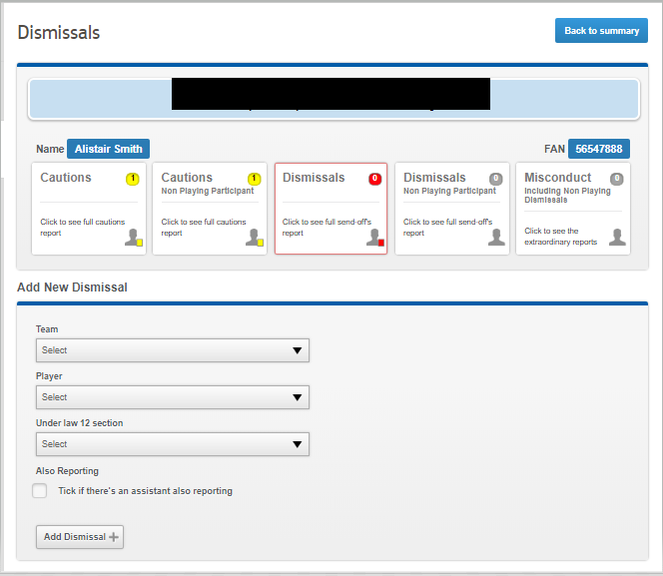

Again, select team, player and under law 12 section options and select the appropriate options.

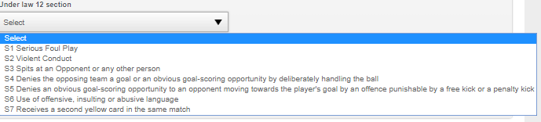

Select the appropriate offence and then click Add Dismissal +



The following box will appear.

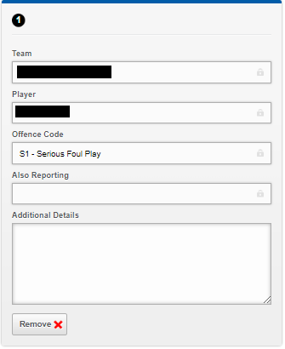

Depending on the Offence, you may want to complete the following boxes…this is supporting information that you submit to the FA should they want to reprimand the player(s) further such as violent conduct.

If you not click back to summary button on the top right page, you will see all entries you have made.

For Other Offences such as game abandonments, abuse from managers, assistants and/or spectators you may wish to report them for disciplinary action which is dealt with by the Staffs FA. For these you need to select and click View / Add extraordinary reports

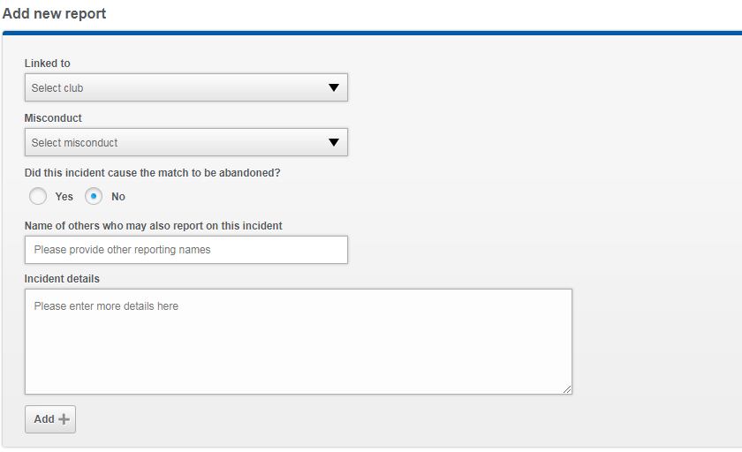

Select the relevant option:

Linked to Club:

A,B Both or not known

Select Misconduct, Yes/No not know.

And then complete the relevant incident details.

Once complete click Add +



Once added, click back to summary, you will see all the information you had added on the system on this dashboard

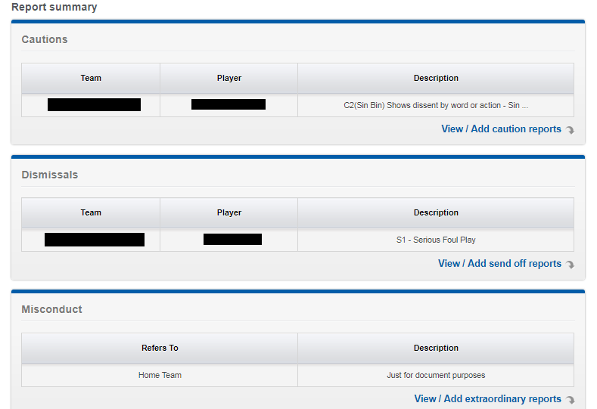

Once you are happy and you have submitted all the relevant information click.



You will be presented with the following notification if successful

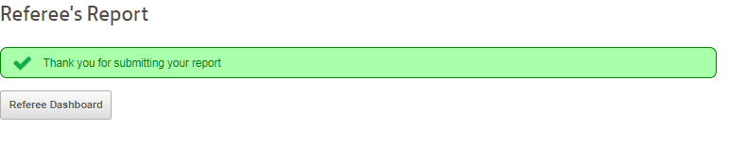

For Dismissals (non playing participant) or Misconduct (including non playing dismissals)

To add a non playing dismissals or misconducts , click either > View / Add extraordinary reports OR click the relevant box

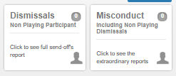

Misconduct :

Complete all the relevant information in the below boxes

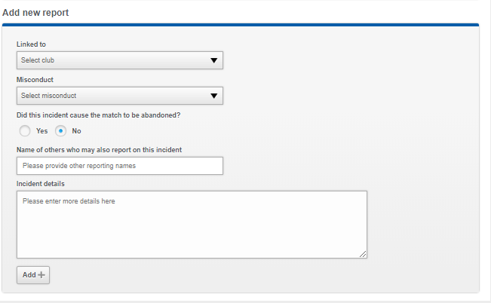

Click ADD to complete the report you will see the following now changed, when added

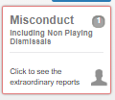 This number will change if you have multiple entries

For the dismissals click –

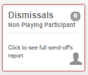 Complete all the relevant details request as below

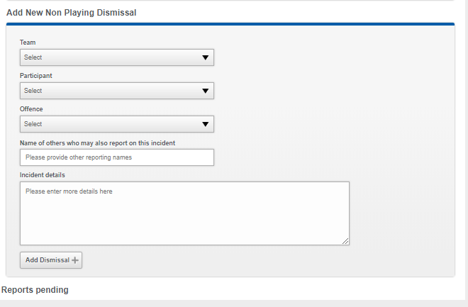

Complete the report and click Add Dismissal you will see when added correctly

That the misconduct counter has increased by 1 – and the dismissal now increased by 1 also,

If you dismiss a manager, it will automatically process itself as a misconduct, that is why the counter has processed + 1

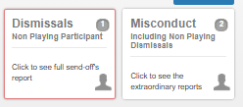

When you have added all the relevant information scroll to the top of the page and click back to summary.



On the main page you will now see a report summary so you can check all the information is correct as expected, all the names and codes are correct and appropriate to the offences recorded.

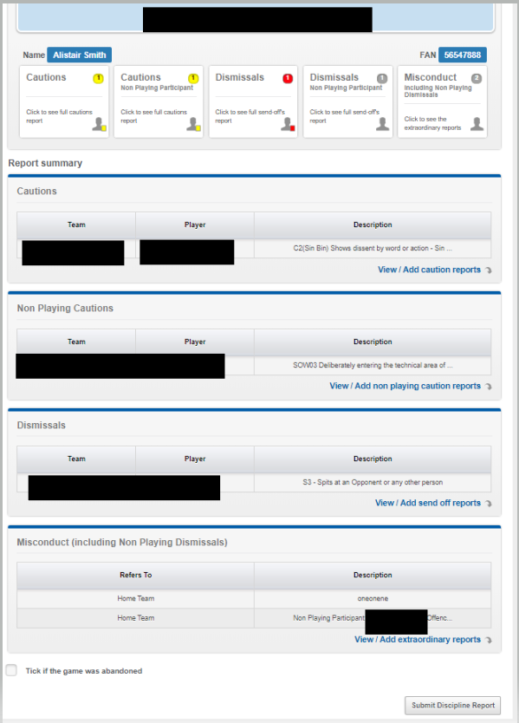

Once you are happy with the report you can click Submit discipline report and that will send it to the FA to process the appropriate fines.